Actually for of () loop was created to make the regular for loop more easier

It works on

Arrays

String

Actually it works on every iterator object

String , Array , TypedArray , Map and Set are all built-in **iterables**, because their prototype objects all have a Symbol. iterator method

We can also make our own user defined iterable object and for of loop will even work on that one too

**But to work with object we have for in loop**

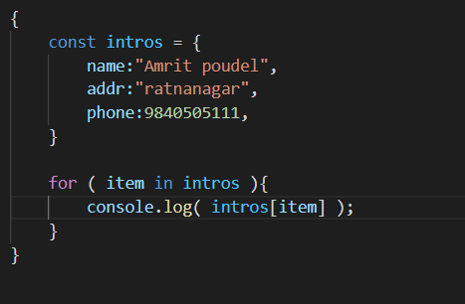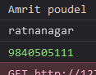

**Now see for of loop**

